LAB 7

**Objectives**

1. Identify the entities of a detailed design for your project.

2. Create detailed designs for a subset of the entities of your project.

3. Assess your team’s technical capability compared to the technical needs of the project.

Designers need to specify the details of the entities that make up the system. These definitions should be sufficiently detailed that the design can be given to a developer and the developer can create the entity as envisioned by the designer.

Once your team starts to develop a design, you should also be developing a better understanding of the technologies and skill levels needed to build the product. As a separate task, this lab will also provide a chance for you to assess your team’s capability to work on the project and identify learning or skill development you may need.

**Procedure**

**Step 1 – Draft a list of entities for your project**

You should consider the following types of entities:

· Screens (or Web pages)

· Database tables

· Files (e.g., data that is stored as part of the system but not stored in a database)

· Code (modules, objects, or functions)

Use Figure 7-1 to list all the system entities that you can identify. A good way to start is to pick one area and focus on that. For example, if your system has a significant user interface, start by trying to name all the screens that would comprise your interface. For each entity you list:

· Enter a type, e.g., “screen”

· Give it a meaningful name, e.g., “CustomerProfile”

· Provide any short notes or explanation needed to identify the screen, e.g., “This screen captures customer information and preferences.”

**Step 2 – Create detailed designs for at least 4 of your entities.**

You will not be able to design all the entities of your system in this lab, but this step will get you started. Pick 4 entities that you think you understand the best at this point, and create a design for them. Every entity should have a name, type, and design details. Templates are provided to help you create detailed design for screens, database tables, and code functions.

**Step 3 – Review your detailed designs.**

After creating your designs, review them for completeness and clarity. Ask yourself this question: “If I was the developer and a designer handed me this design, would I know what to build without needing to ask a lot of questions?

If you have created the design entities as a team, set them aside for a few minutes before review each one. If you have worked in sub-groups within your team to create the designs, then exchange designs so the reviewer is a different person than the creator of a design.

Revise your designs based on the review.

**Step 3 – Assess your team’s capability to complete this project.**

Once you have an architectural overview and the beginning of a design, you should be able to assess capability and identify things that someone on the team may need to learn. Use Figure 7-5 to summarize this information.

3.A – List the technologies you need for your project using the column on the left. Consider things such as programming languages, operating systems, specialized data sources, software libraries, support tools, and hardware.

3.B – List each team member at the top of a column, and then evaluate that person’s knowledge of the technology in each row. For the column for each team member, use the following values:

1 – No knowledge or not much relative to the needs of this project

2 – Enough knowledge to accomplish part but not all of this project

3 – Knowledge probably sufficient for this project

3.C – Discuss within your team how you will start to gain capabilities that you are missing. You do not need to turn in results of this discussion in this lab, but will need to address this in the coming weeks.

**What to Turn In**

In order to obtain full credit for this lab, ***each team*** must turn in:

1. Figure 7-1 – Possible System Entities

2. Detailed designs for at least 4 entities in your system. Use the templates in Figures 7-2 through 7-4 to get started.

3. Figure 7-5 – Team Capability Assessment

**Figure 7-1 – Possible System Entities**

Product: DragonEvents

Team: Team 2

Date: 11/09/2017

|  |  |  |
| --- | --- | --- |
| **Type** | **Name** | **Description or Notes** |
| Screen | DragonEvents Homepage | This screen serves as a main page of DragonEvents. |
| Screen | SignUp Page | Users can create an account on this screen. |
| Screen | EventDetails | This screen captures details of events listed. |
| Database Table | user_tbl | This table holds user information. |
| Screen | Event Editing | This screen allows users to edit event details. |
| Database Table | events_tbl | This table holds the events that are submitted by the user. |
|  |  |  |
|  |  |  |
|  |  |  |
|  |  |  |
|  |  |  |
|  |  |  |
|  |  |  |

**Figure 7-2 – Template for Detailed Design for a Screen**

**Name**: DragonEvents Homepage

**Type**: Screen

**Purpose**: This screen is needed to meet requirement 3.1-6 Allow users to sign up to submit events.

This screen will be the homepage for DragonEvents. It will display all of the events along with the ratings that users have submitted to our website. In addition, the home screen will also be a gateway to user information and account management.

**Description**: Figure 01 shows the layout for this screen. This screen allows users to sign-in or sign-up and serves as main page of the DragonEvents.

The screen contains the following elements; user login or sign-up and account management for user managing. Event poll is set up to give rating and reliability of the event and this feature will be available once the user is logged in.

Layout:

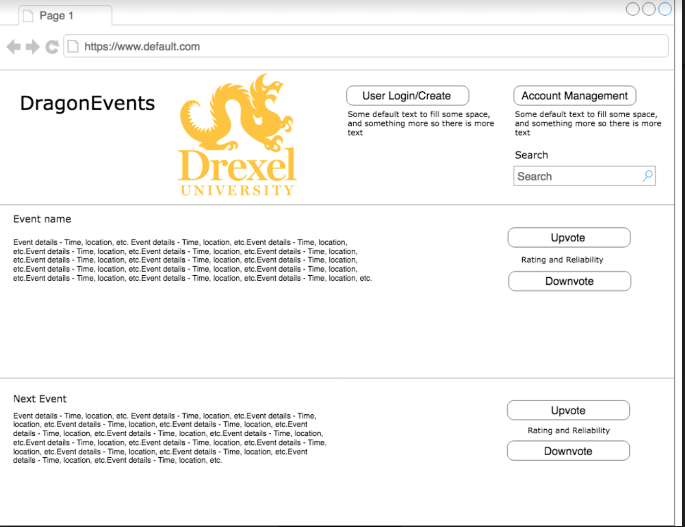

**Figure 01 - Homepage Screen**

**Name**: Event Editing

**Type**: Screen

**Purpose**: This screen is needed to meet requirement 3.1-2 Receive Event Submissions and 3.1-3 Allow for event hosts to edit their own events.

**Description**: : Figure 2 shows the layout for this screen. This screen will be the event editing page for DragonEvents. This page allows submission and editing of event details from users using event submission form.

The screen contains the following elements; submitting a new event or editing existing event,

Layout:

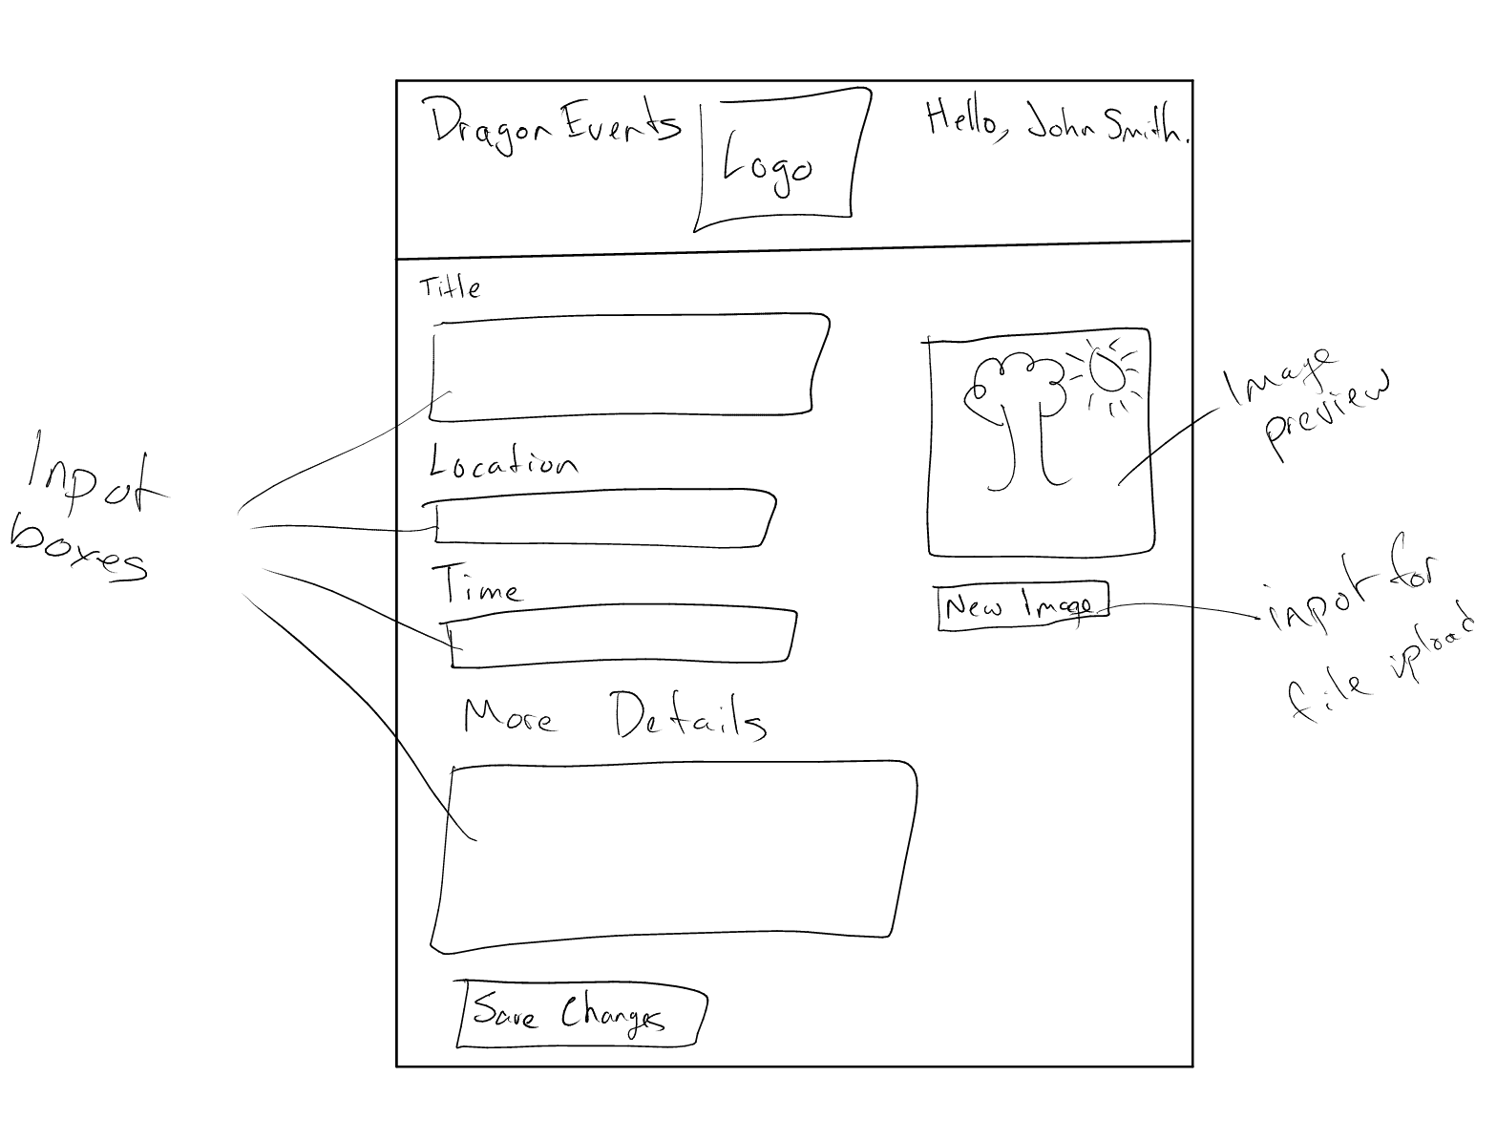

**Figure 02 - Event Editing Screen**

**Figure 7-3 – Template for Detailed Design for a Database Table**

**Name**: User_tbl

**Type**: Database Table

**Purpose**: This table is needed to meet requirement 3.4 Data requirements.

**Description**: Figure 03 shows the contents for this table. This table gives details of the user entity. One row of this table represents The name of the data while the others give more detail of the data.

**Table Contents:**

|  |  |  |  |
| --- | --- | --- | --- |
| **Data Element Name** | **Data Type** | **Key** | **Notes** |
| FirstName | VARCHAR |  | This will hold the user's first name. |
| LastName | VARCHAR |  | This will hold the user’s last name. |
| Email | VARCHAR |  | This is the user’s email |
| ID | INT | Primary | Unique ID for the user |
| Password | VARCHAR |  | Holds the user’s password |
|  |  |  |  |
|  |  |  |  |

**Figure 03 -User_tbl Database Table**

**Name**: Event_tbl

**Type**: Database Table

**Purpose**: This table is needed to meet requirement 3.4 Data requirements.

**Description**: Figure 04 shows the contents for this table. This table gives details of the event entity. One row of this table represents the title of event and details of the event.

**Table Contents:**

|  |  |  |  |
| --- | --- | --- | --- |
| **Data Element Name** | **Data Type** | **Key** | **Notes** |
| ID | INT | Primary | Unique ID for the event |
| Title | CHAR |  | Holds the title of the event |
| Date | DATE |  | Holds the Date for the event |
| Description | VARCHAR |  | Holds the description of the event |
| Location | VARCHAR |  | Holds location of an event |
| owned_by | INT | Foreign | User ID that owns event (references user_tbl) |
|  |  |  |  |

**Figure 04 - Event_tbl Database Table**

**Figure 7-5 – Team Capability Assessment**

|  |  |  |  |  |  |
| --- | --- | --- | --- | --- | --- |
|  | **Harley S** | **Rahul G** | **Saffat H** | **Nicholas N** | **Haley L** |
| **HTML/CSS** | 1 | 1 | 3 | 2 | 2 |
| **mySQL** | 2 | 2 | 3 | 1 | 1 |
| **JavaScript** | 2 | 1 | 3 | 1 | 1 |
| **Node.JS** | 1 | 1 | 1 | 1 | 1 |
|  |  |  |  |  |  |
|  |  |  |  |  |  |

** The table values represent an assessment of team member capabilities. The values are:

1 – No knowledge or not much relative to the needs of this project

2 – Enough knowledge to accomplish part but not all of this project

3 – Knowledge probably sufficient for this project